An ideal gift for members of the college community – past and present
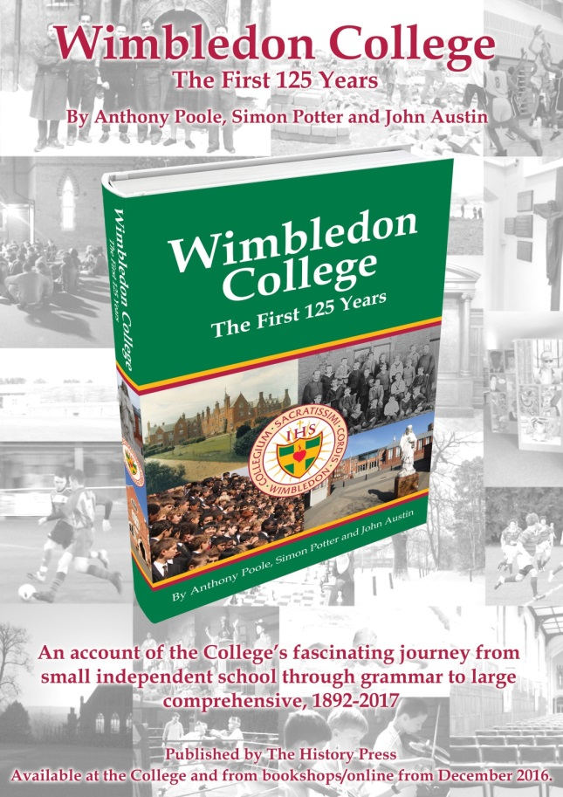 It is available at a price of £25.00

You may purchase items in one of the following ways:
- Current parents and staff can pay via your School Gateway accounts. Purchased items can be collected by your son from Mrs Lawlor the College Secretary.
- Former staff and pupils can pay online via the following link
https://www.parentpay.com/ParentPayShop/Foc/Default.aspx?shopid=51
[If you use this link you do not need to put an invoice number but please ensure that you clearly enter the specific name and quantities of items you want to order, and that you indicate whether you will collect the items or if you want them posted – in the latter case please refer to the postage and packaging prices listed on the order form (on the following page), and include that in the price of your payment.]
- Alternatively, please complete the order form below on the College website and return it to Mrs Lawlor, the College Secretary, at the school [Wimbledon College, Edge Hill, London, SW19 4NS]
Wimbledon College – The First 125 Years
I would like to purchase ______________ copies of ‘Wimbledon College, The First 125 Years’
at £25.00
- If you would like us to post the book to you, please fill in your address below and work out your postage charge at the bottom of this page.
- If you would like to collect your book from school you do not have to pay postage & packaging.

*I will collect my order from the school. Please contact me by email my book is available for collection.
Email address:
Contact Number:
*I require my copies posted to the following address
[I agree to pay package and postage as outlined below]

Name [Please print]:
Address [Please print]:
Cost of postage and packing
- If you order a book please insert the number of copies below & calculate the cost of packaging (the price is a multiple of the number of books you are ordering),

*UK £3.00 x _____________copies Total £ _____________
*Europe £10.00 x ____________ copies Total £ _____________
*Worldwide £16.50 x ____________ copies Total £ _____________
Total cost [items(s) plus p&p] £ __________________
Please make cheques payable to ‘Wimbledon College’

