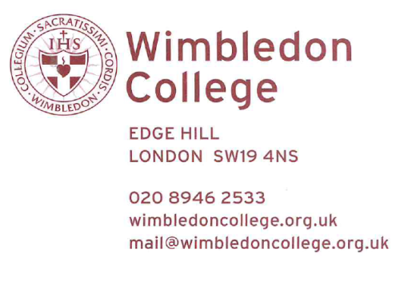

14th December 2020
Dear Parent

We are fortunate to have some of our boys who are bilinguals and as such we would like to offer the opportunity to those pupils to sit their GCSE exams in their native language (Spanish and French – as externals, Portuguese, Italian, Russian, Polish, German, Arabic).
However, we must point out that as most of those languages are not taught at the college, we do not have the expertise to support or guide your son in the subject (apart from French and Spanish).
If you feel that your son has a good writing level in his native language, and if you wish for him to sit a GCSE in June 2021, please do return a signed letter to the MFL department specifying the language and his current level.
Please note that due to Covid-19, Ofqual has removed all the speaking tests for all languages, therefore they will be assessed only on listening, reading and writing.
Best regards

N Anderson
2nd in charge
MFL department

